**SOLT calibration of VNA and fixture removal**

Contents

Introduction 1

Stage I: SOLT calibration of VNA and the bench coaxial cables 1

Stage II: De-embedding the fixtures 9

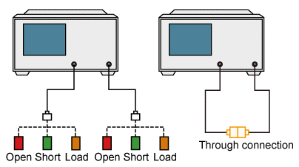

# Introduction

The present guide aims to show how to extend the reference measurement plane up to the sample under test, when the measurement track includes standard coaxial cables and non-standard fixtures, for example, a PCB cell or cable probe with free ends, see below. Compared to the procedure we used before, VNA and cables are now calibrated separately using the Rohde&Schwartz (R&S) coaxial calibration standards. Then, the fixtures that are connected to the cables, are virtually removed via de-embedding. Note that it is still necessary to compensate for the phase incursion along the sample (delay time compensation).

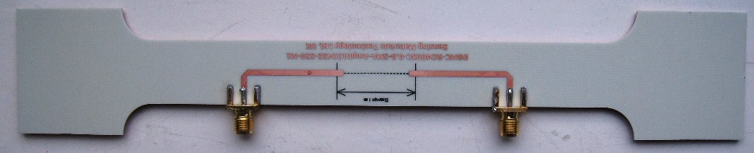

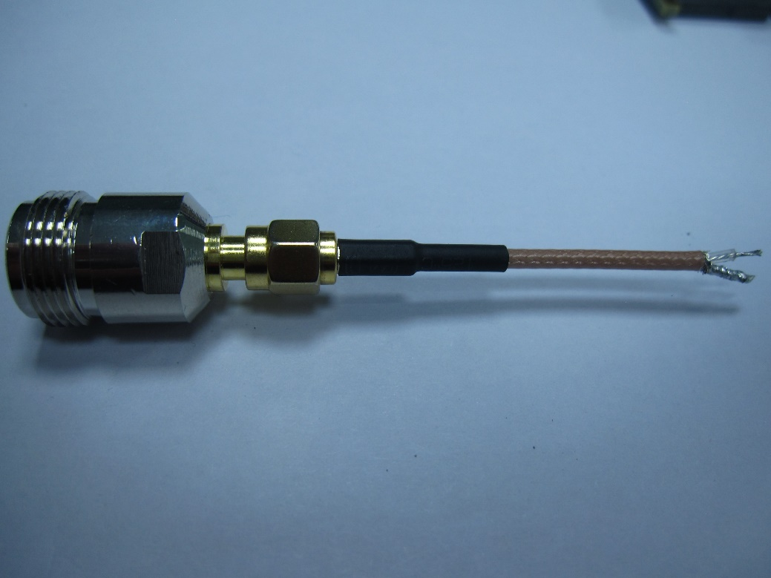

Examples of non-standards fixtures for testing samples: PCB cell with microstrips and

a piece of coaxial cable with free ends where the sample is attached

In Sections II and III, we explain how to perform the standard SOLT calibration (or TOSM in terms of R&S) and enable deembedding of fixtures with SP2 files already created for them and uploaded on VNA. In Section IV, we explain how to create S2P files for new fixtures using our algorithms written in Python. The program codes are saved in Appendix.

# SOLT calibration of VNA and bench coaxial cables

1. Activate the switching box control panel by clicking the icon “SwitchingBox” on Desktop. Wait until the temperature and humidity indicators will show their values.

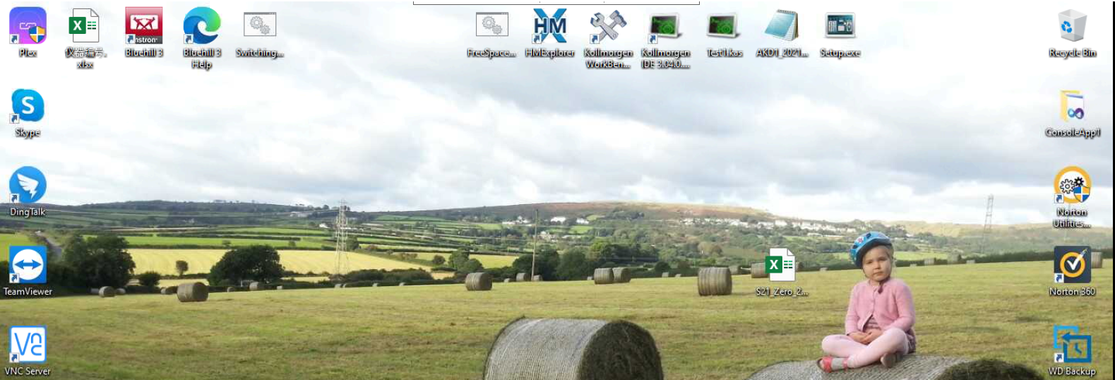

1. Click on the BENCH MEASUREMENTS (indicator turns green when the branch is enabled).

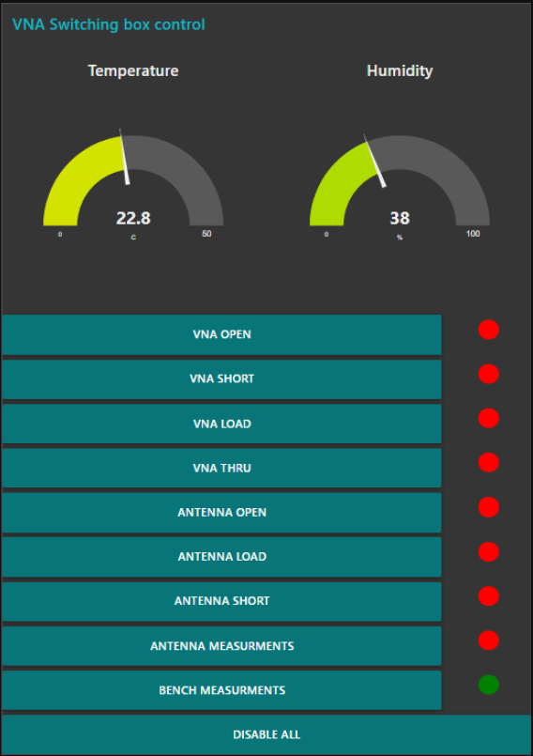

1. Choose the start and stop frequencies (maximum, 100 kHz – 20 GHz, or narrower range), number of frequency points (5000, less or more), power (0 dBm is recommended), and IFBW (10 kHz is recommended).

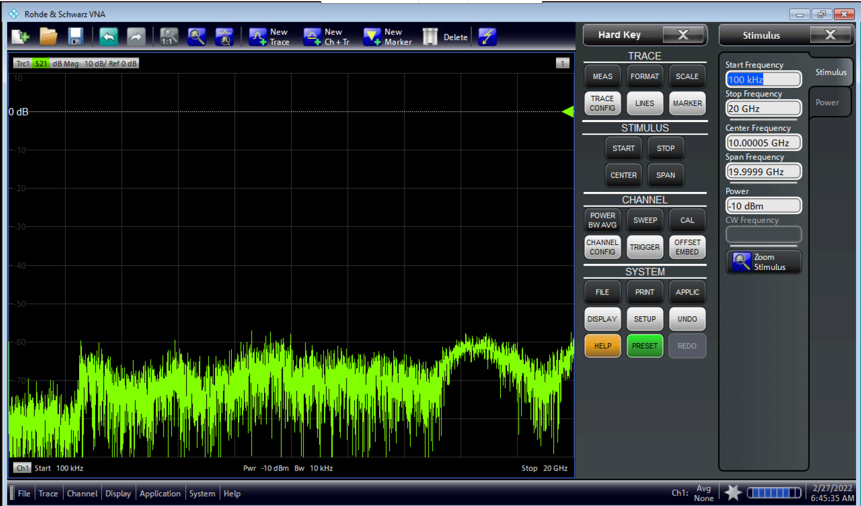

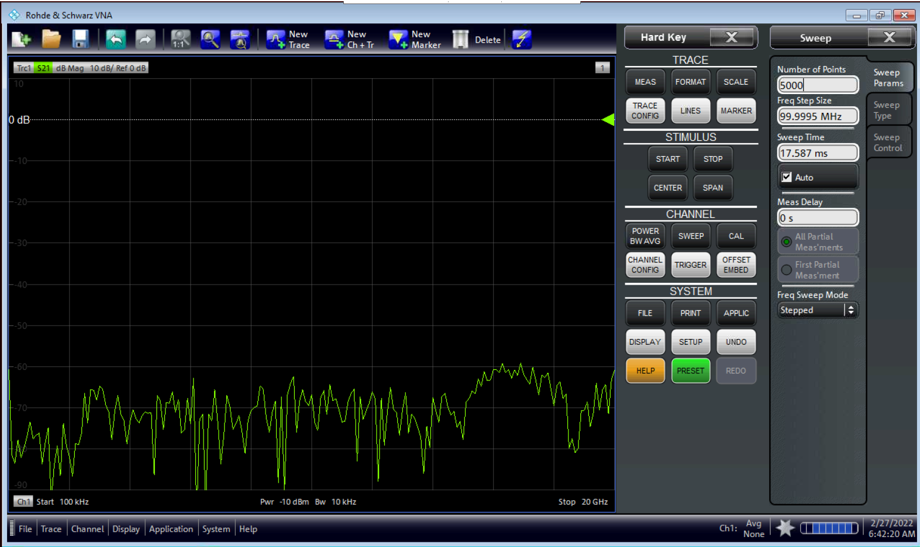

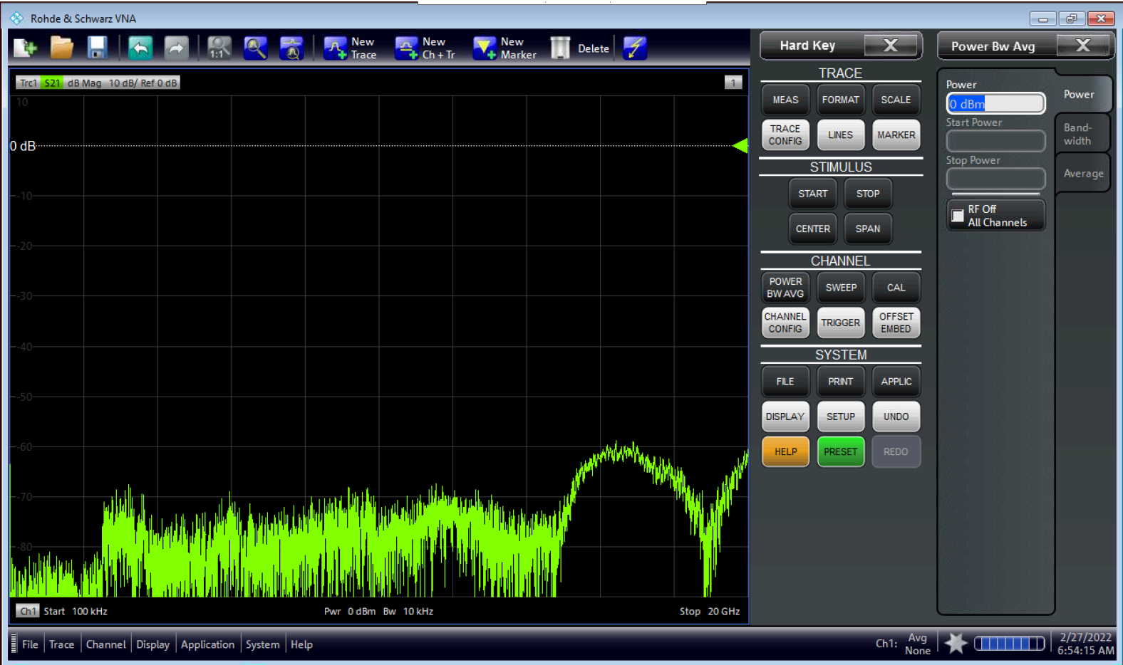

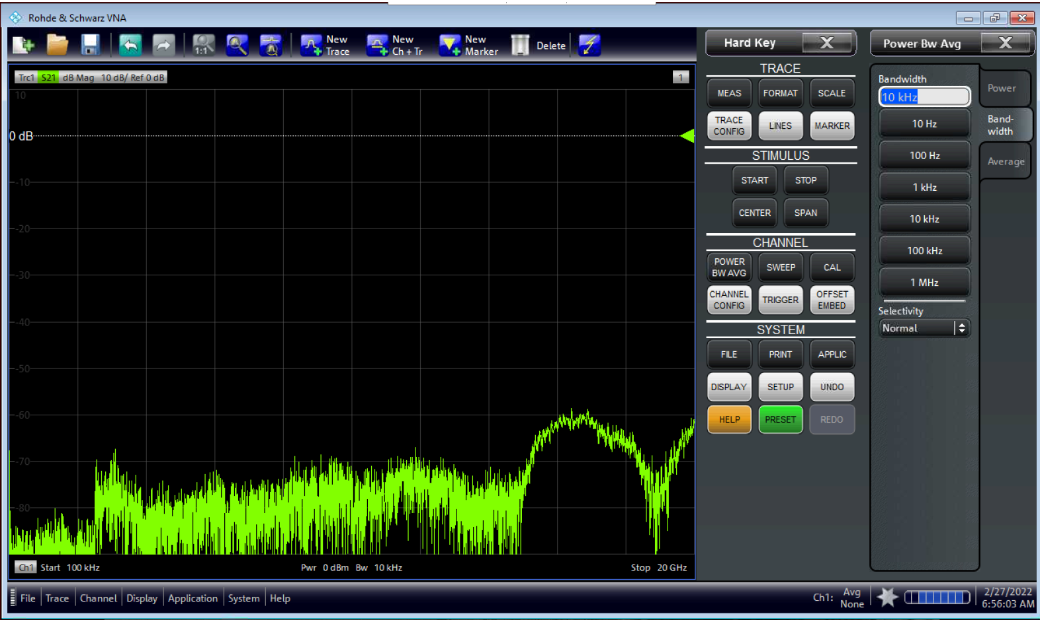

1. Start performing SOLT – SHORT, OPEN, LOAD, THRU calibration (TOSM in terms of R&S), using the coaxial standards which are connected to the bench cables.

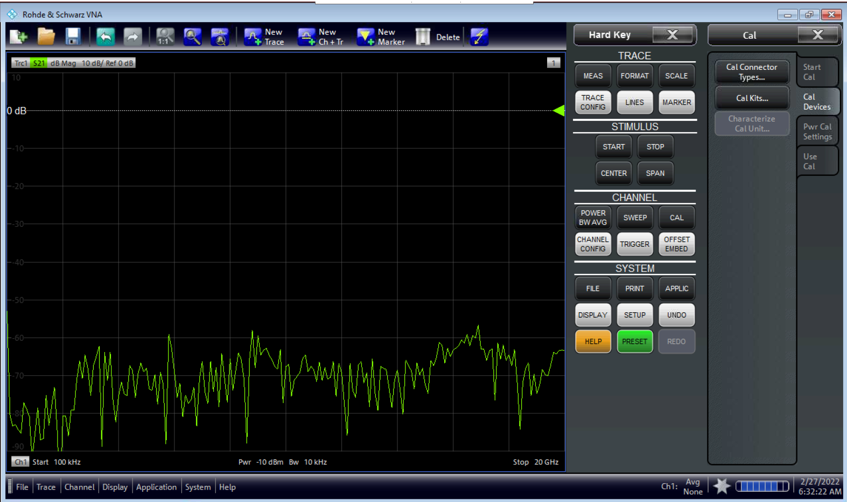

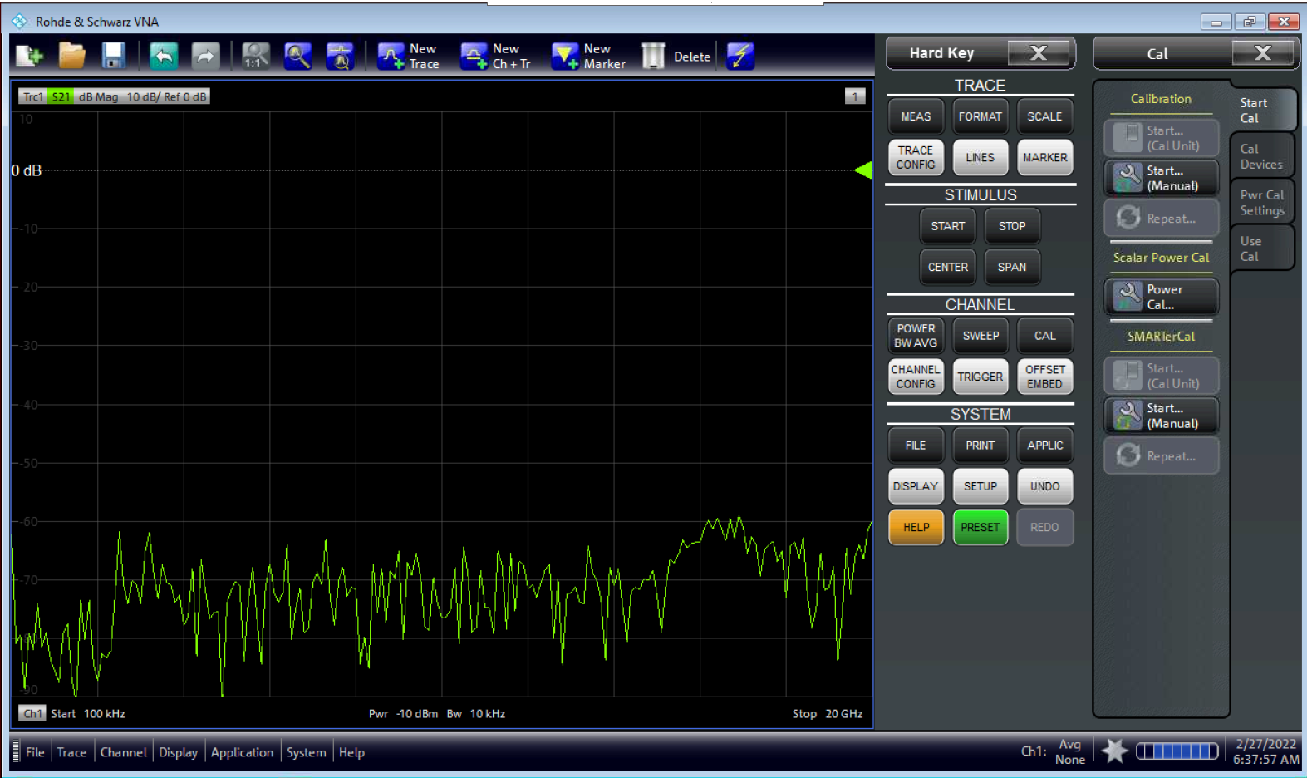

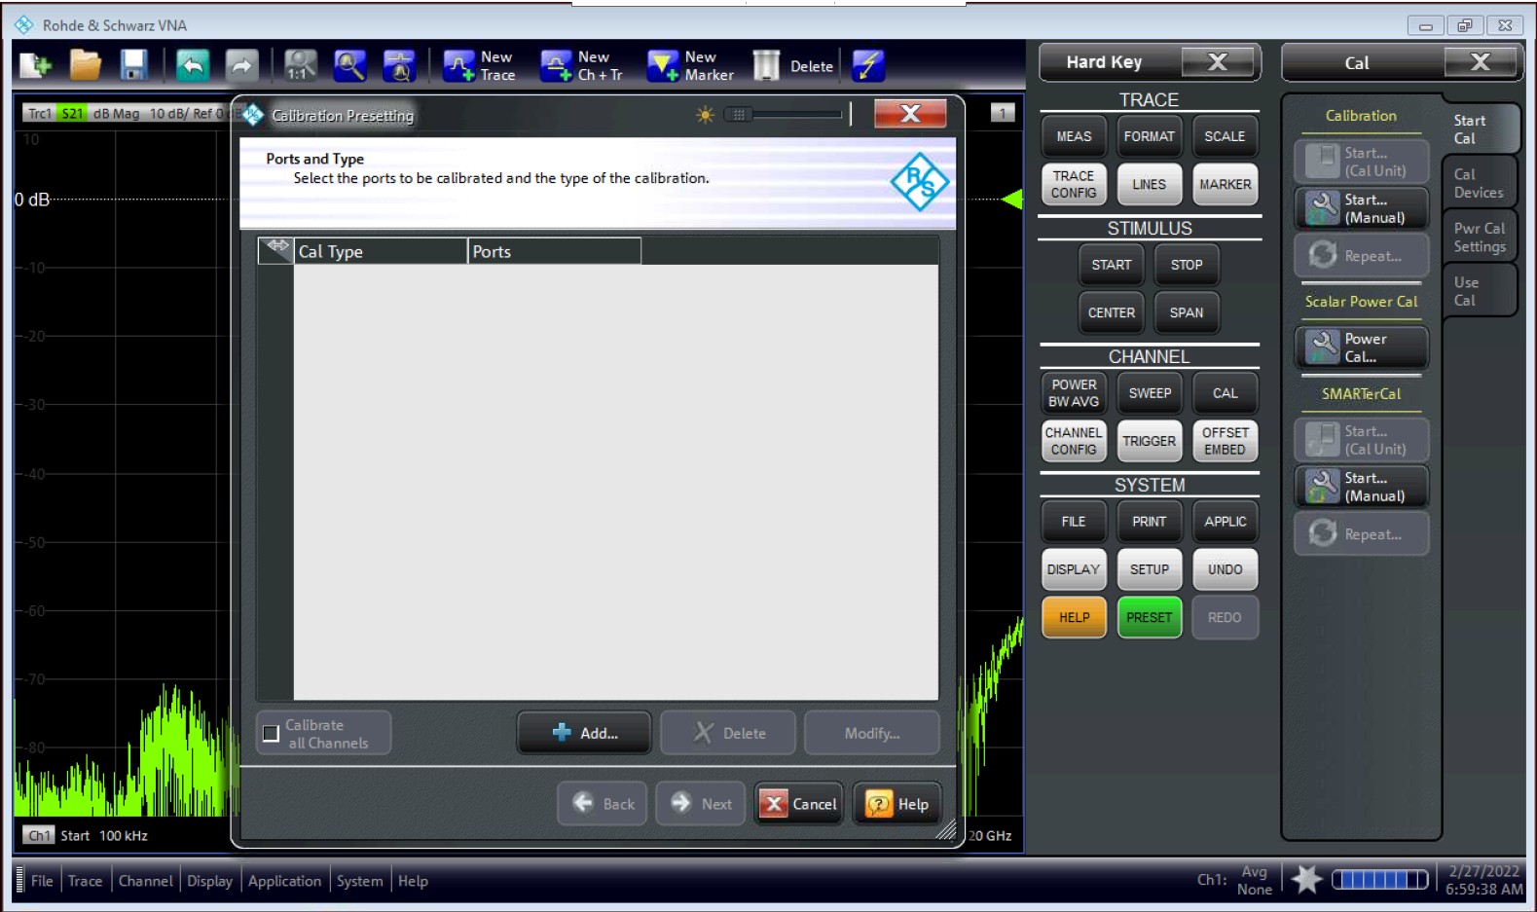

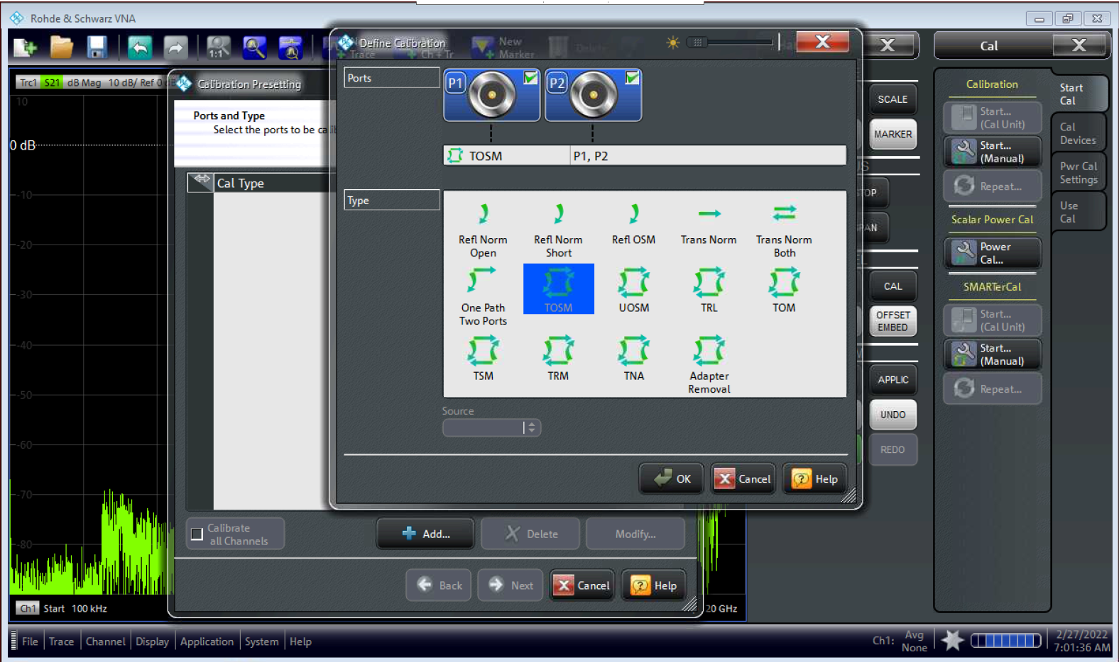

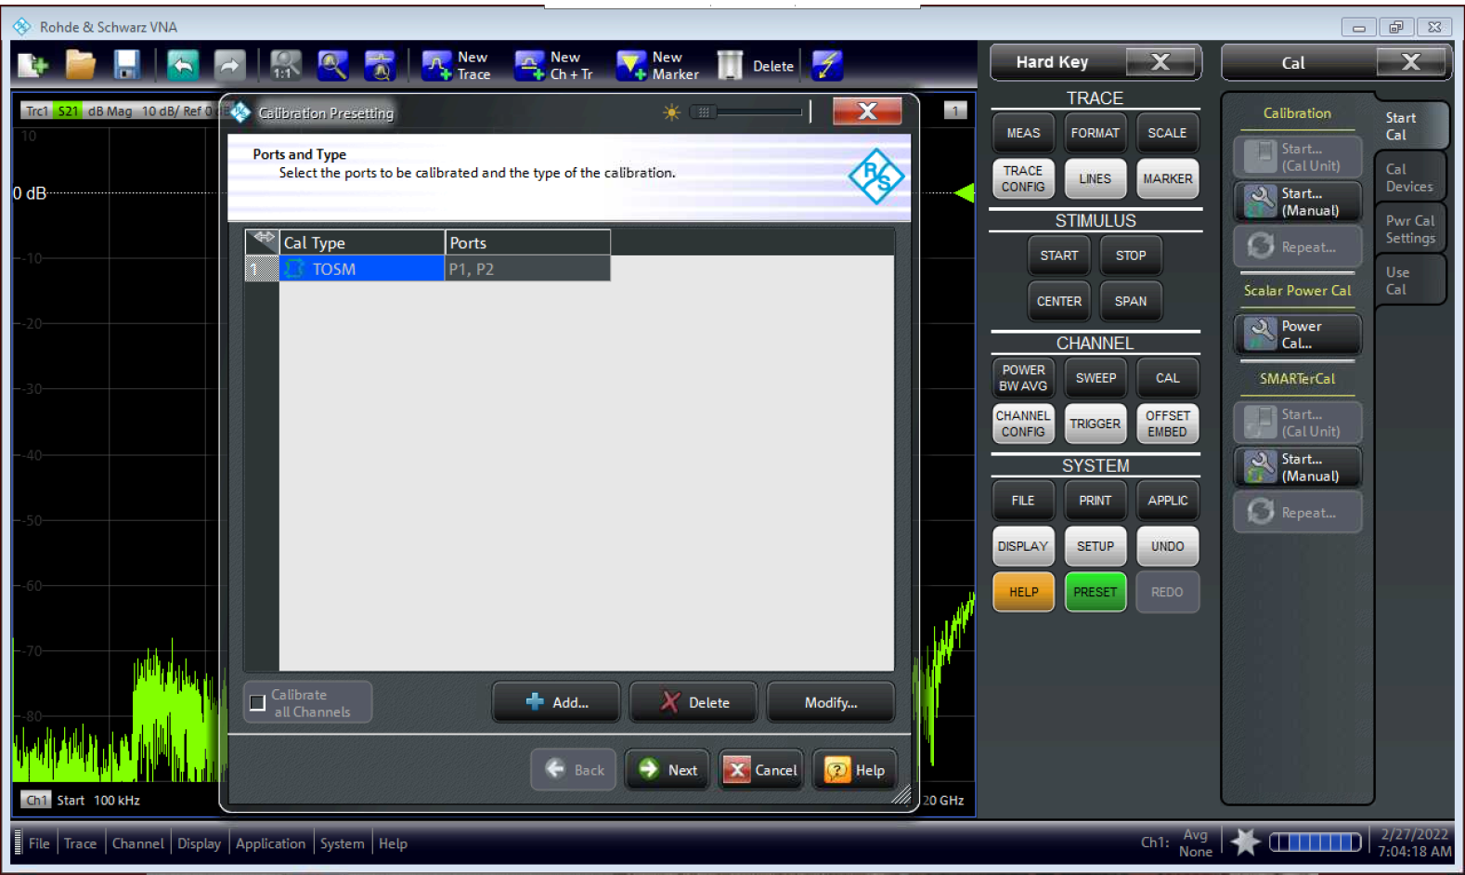

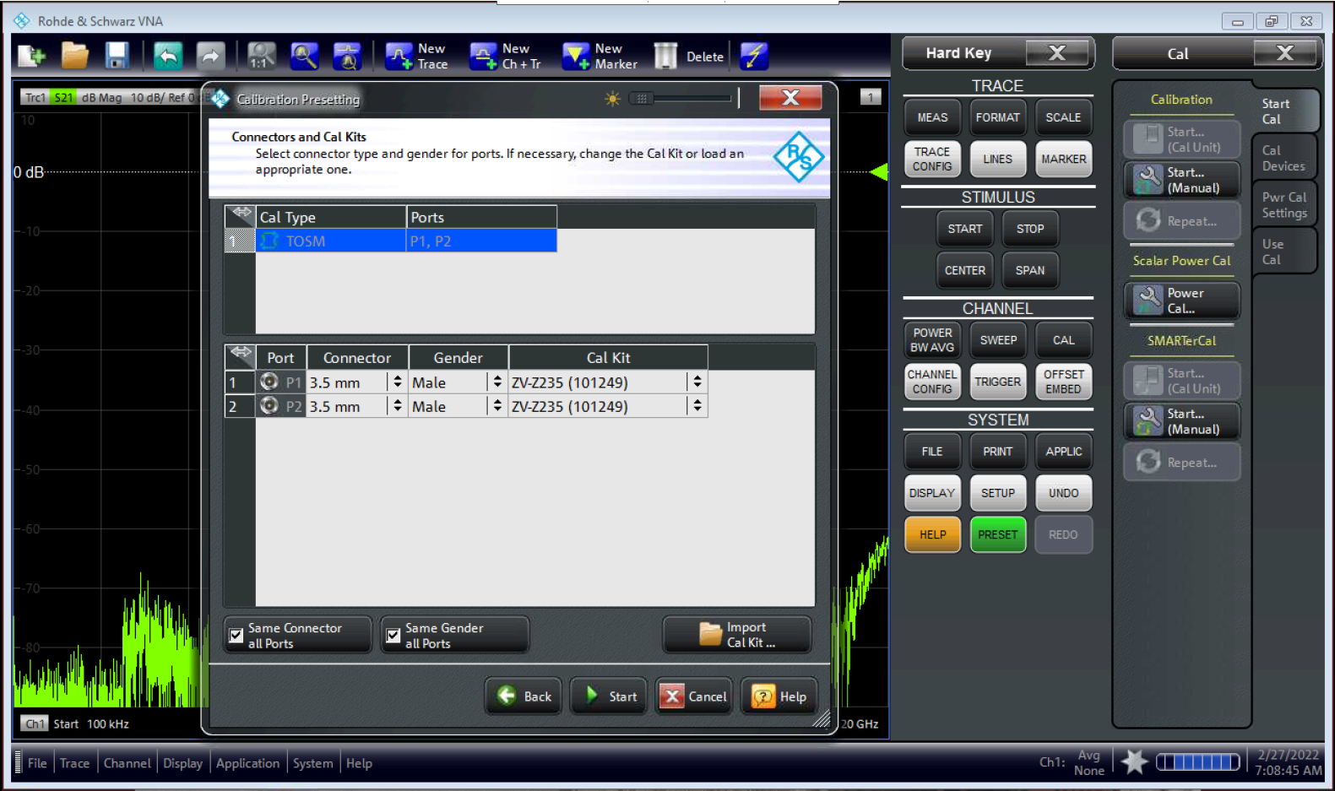

Check your calibration kit!

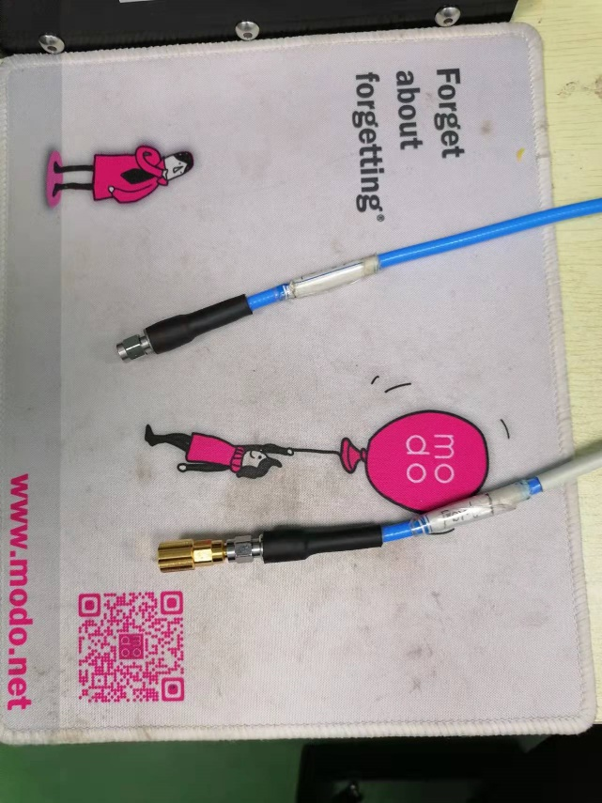 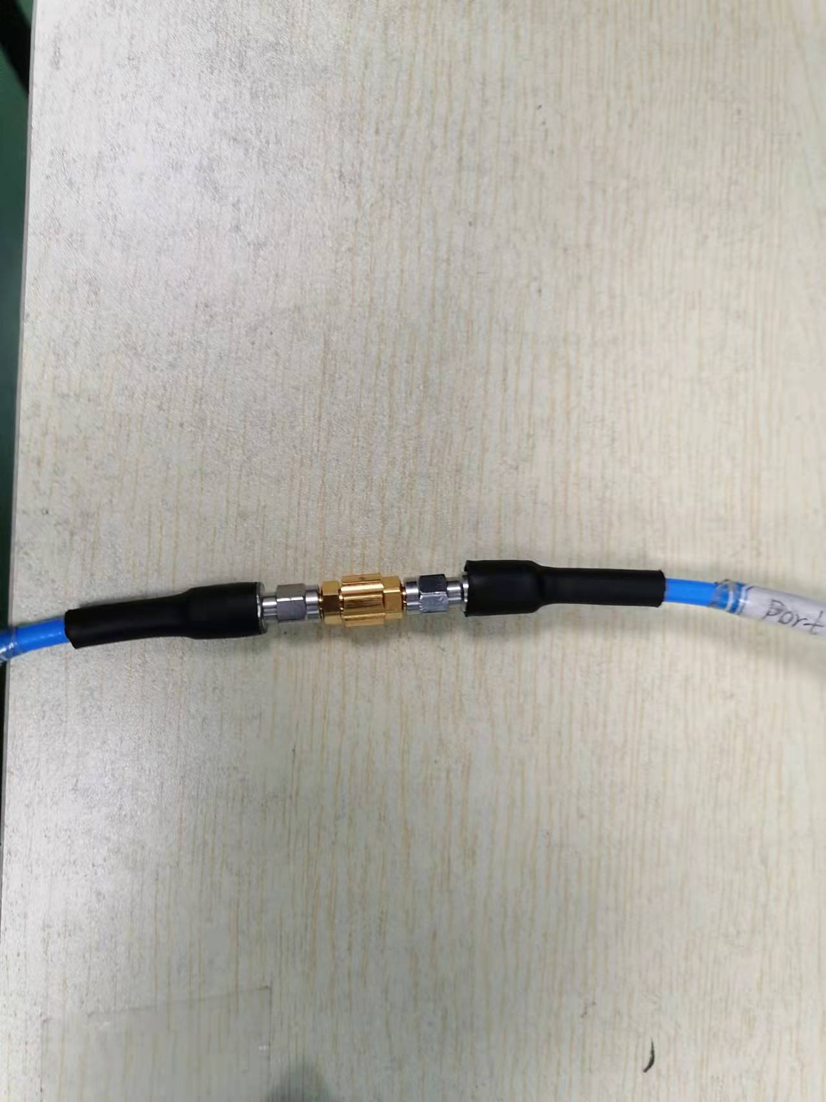

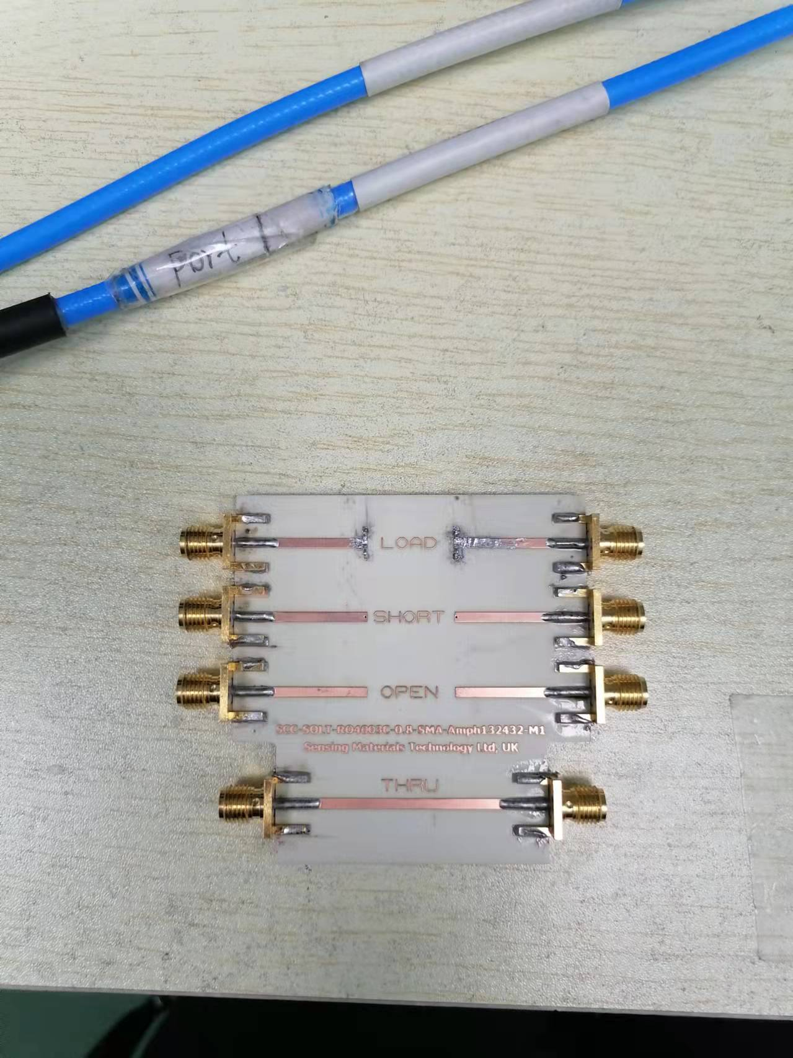

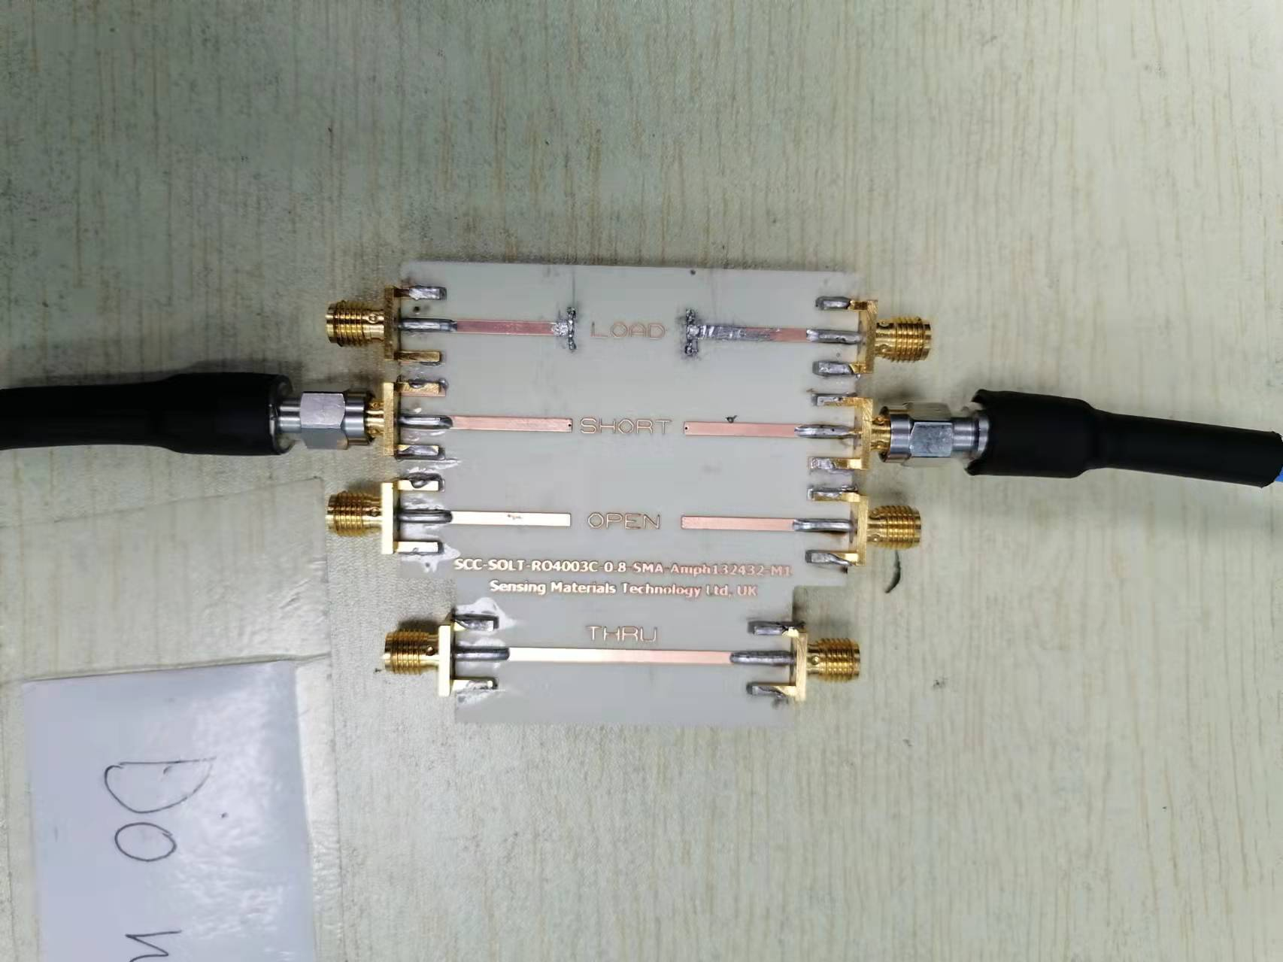

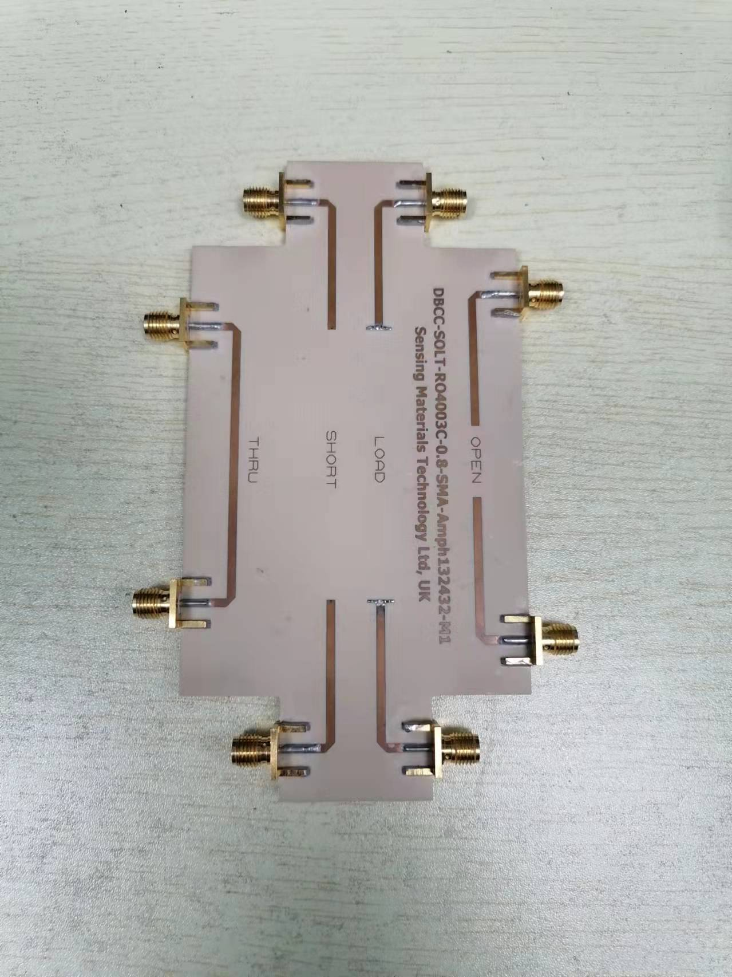

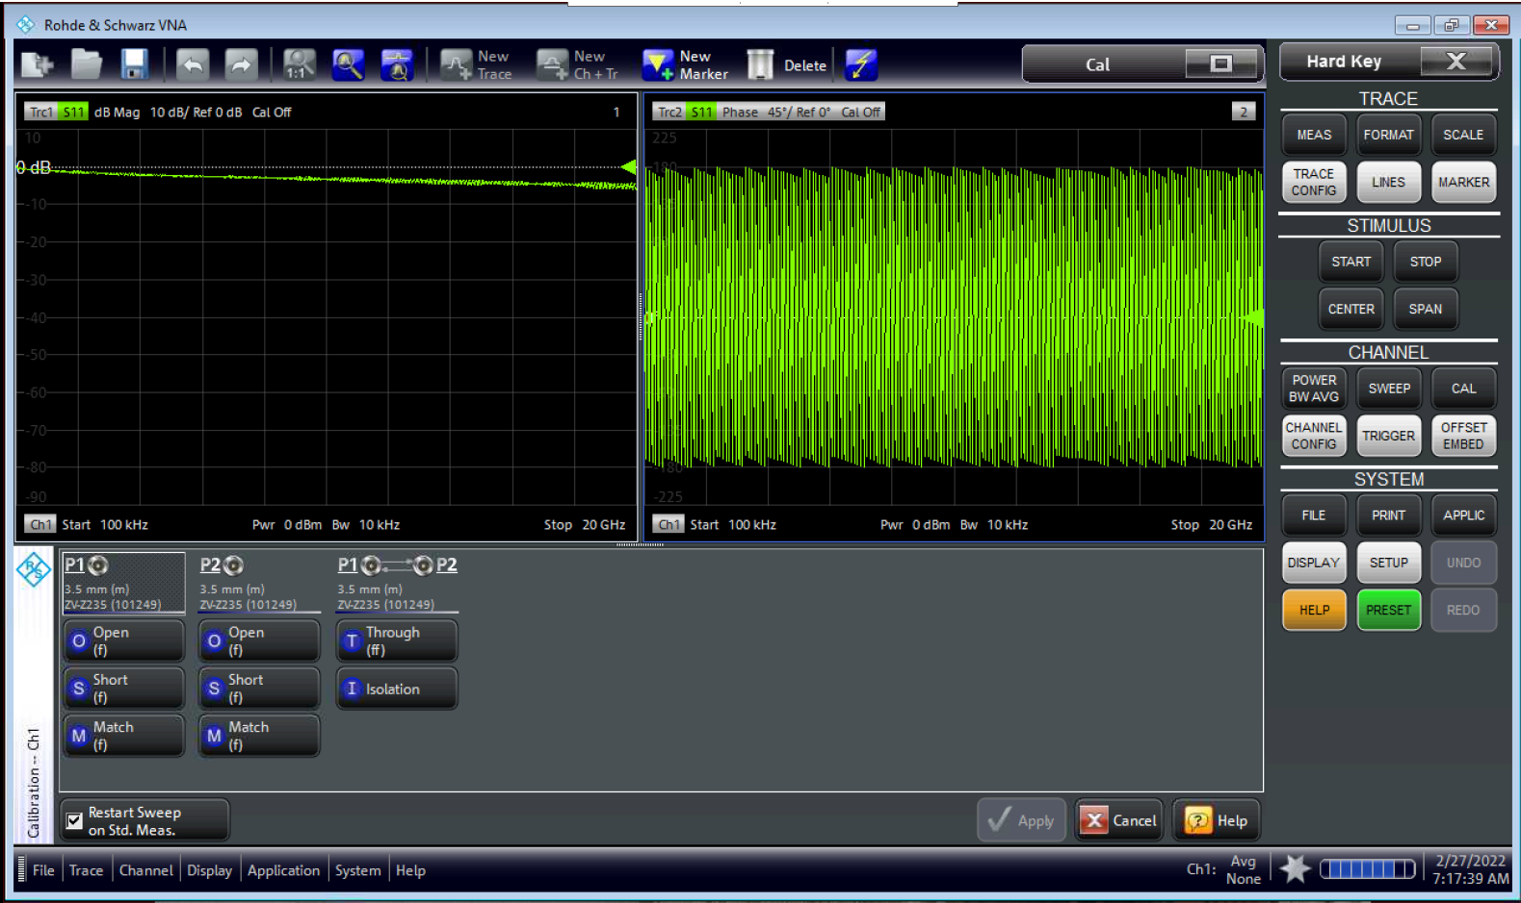

Connect the coaxial calibration standards (SMA female): SHORT, OPEN, MATCH, THRU

Do not forget to Apply the calibration

No need the Isolation

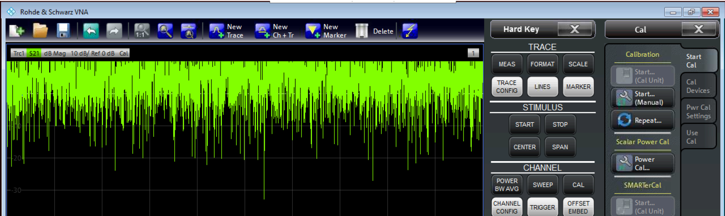

Check that the calibration has been enabled

# Fixture de-embedding

For new fixtures, in Section IV we explain how to create S2P files for them. Once created and uploaded on VNA, the files can be easily recalled when enabling the de-embedding after SOLT.

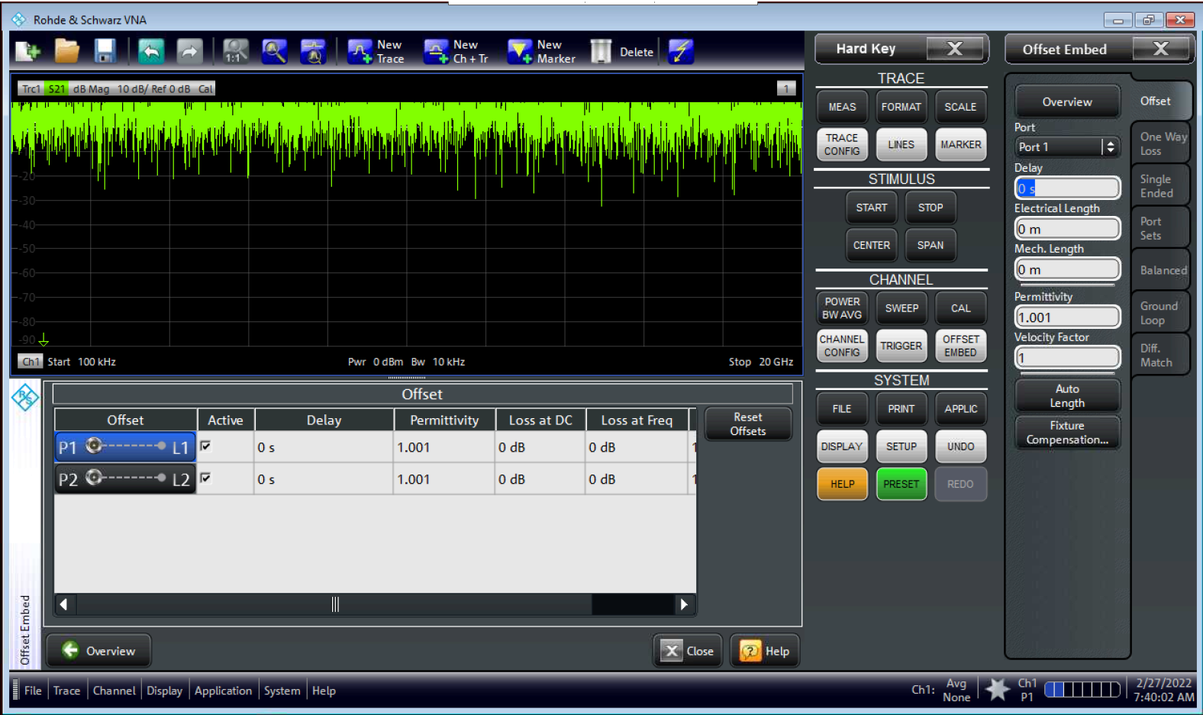

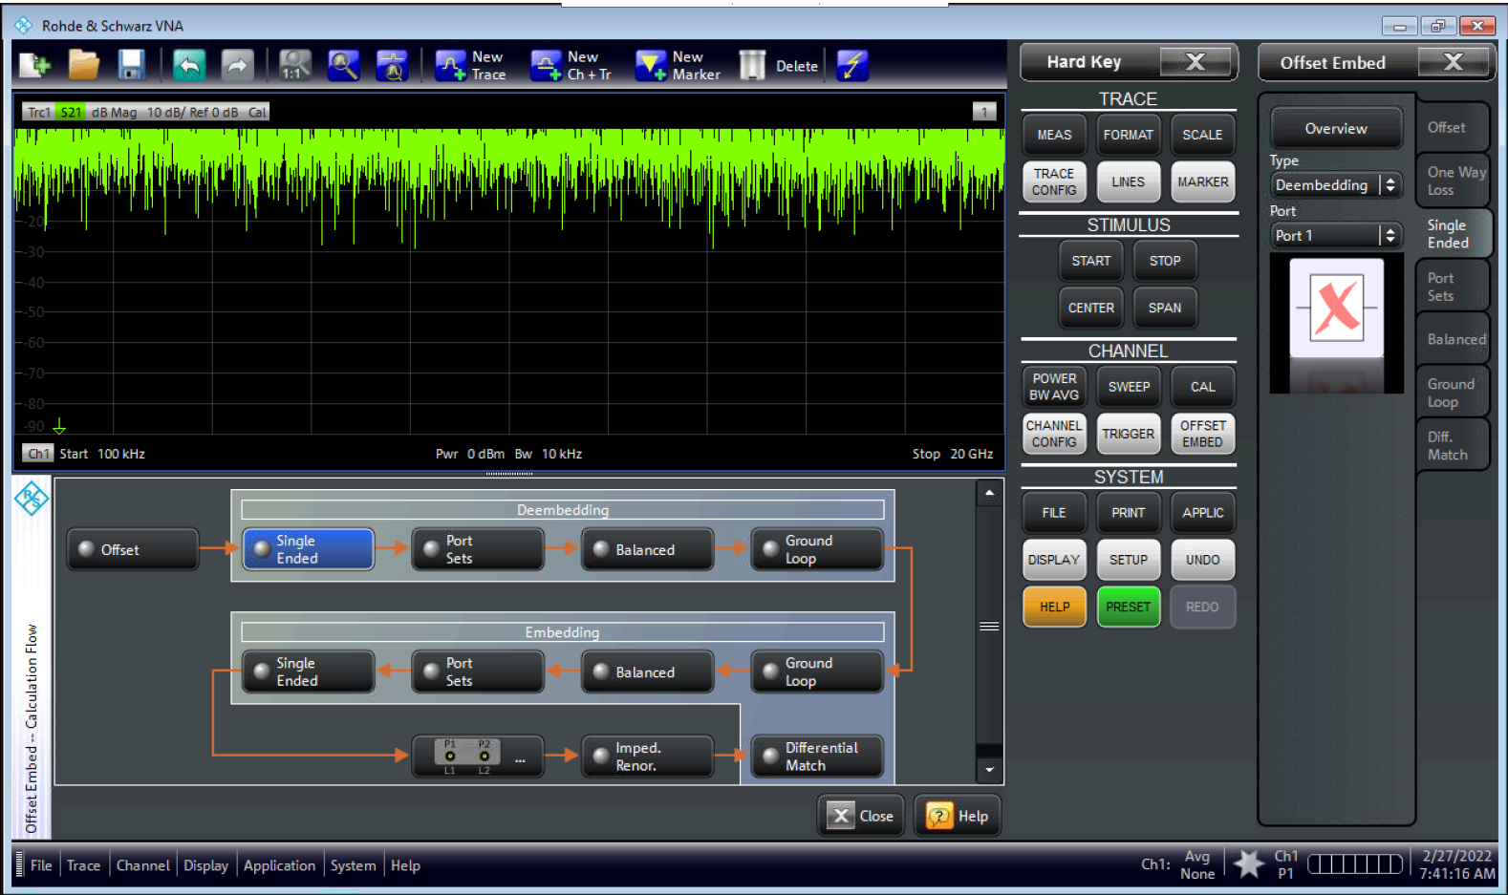

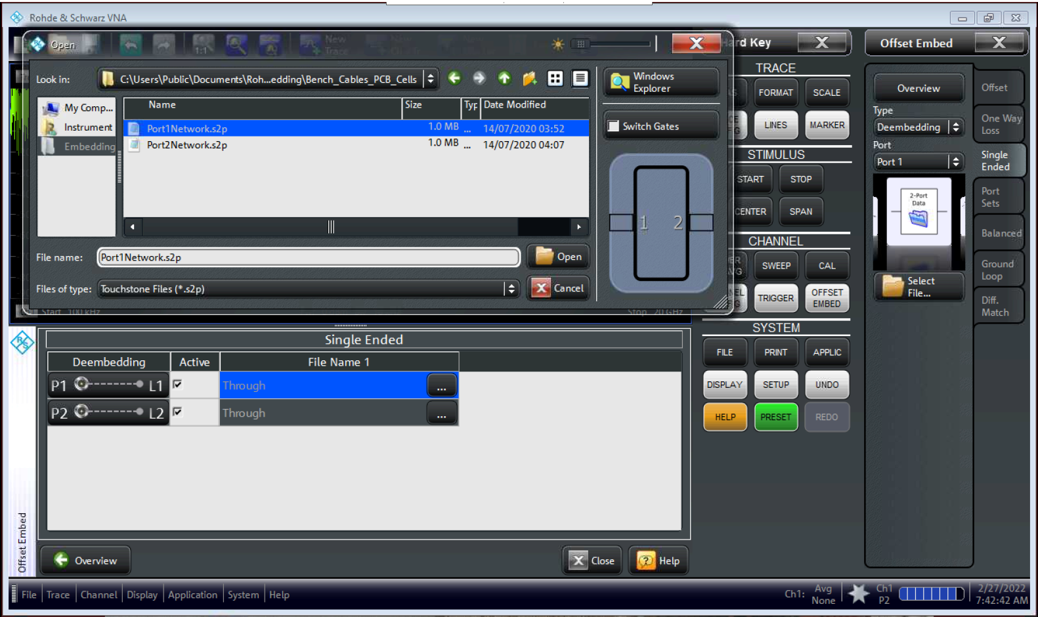

C:\Users\Public\Documents\Rohde-Schwarz\Vna\Deembedding\Bench_Cables_PCB_Cells

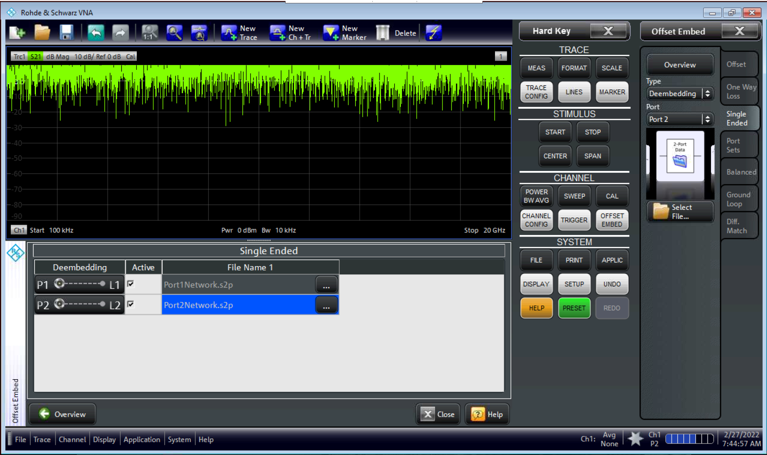

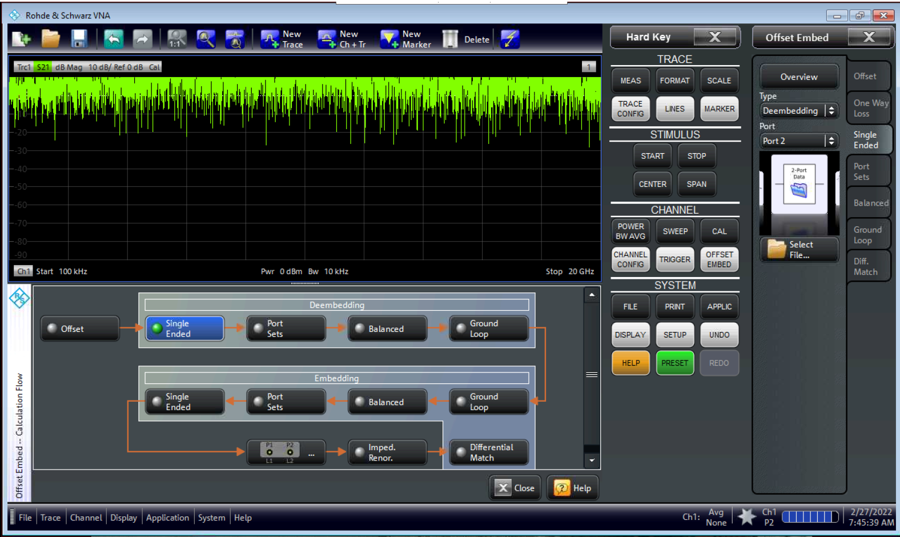

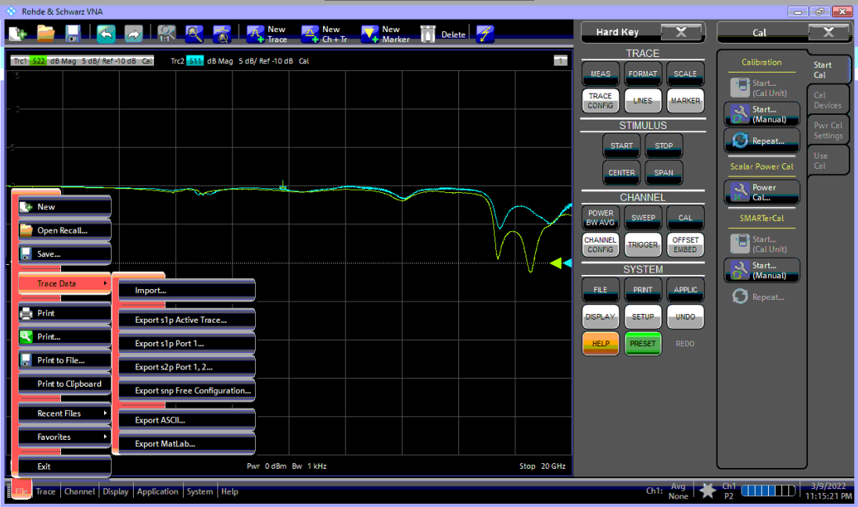

C:\Users\Public\Documents\Rohde-Schwarz\Vna\Deembedding\Bench_Cables_PCB_Cells

